Accessibility Guide for Cherry Tree Barn
hazelandlodge@gmail.com, 07977 155851, www.hazelandlodge.co.uk
Contact for accessibility enquiries: Marion Bedford
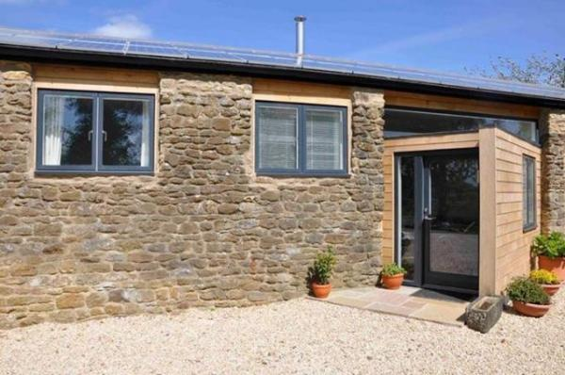

Welcome
Cherry Tree Barn is a luxury 2 bedroom holiday barn sleeping 4 (plus baby) in the stunning Wiltshire countryside with lots to do on the doorstep, including access to a heated swimming pool and tennis court.

At a Glance

Level Access
- There is level access from the main entrance to:
  - Washing machine provided in Kitchen
  - Lounge
  - Gardens
  - Tennis court

Access with steps
- There are steps from the main entrance to:
  - Bedroom
  - Swimming Pool changing area
  - Swimming Pool
  - Gym changing area

Bedrooms
- We have non-allergic bedding.

Visual
- The walls and the doors have high colour contrast.

General
- Staff are available 24 hours a day.
- We have emergency evacuation procedures for disabled visitors.

Getting here
Hazeland Lodge
Bremhill
Calne
Wiltshire
SN11 9LJ

Travel by public transport
- You can get to Cherry Tree Barn by bus and train.
- The nearest bus stop is on the A4 at Study Crossroads, 1 mile from Cherry Tree Barn, here you can pick up the 55 towards either Chippenham or Swindon. The bus stop is 1.30 miles / 6.6 km from Cherry Tree Barn.
- The nearest train station is Chippenham. The train station is 3.4 miles / 5.5 km from Cherry Tree Barn.
- Cherry Tree Barn is accessed by car along a narrow country lane
- You can get a taxi with Calne Taxis by calling 01249 821111.

Parking
- We have a car park. The parking is less than 50 metres from the main entrance. Parking is free.
- There is a drop-off point at the main entrance. The drop-off point has a dropped kerb.
- From the car park to the entrance, there is level access.The route is 1000mm wide, or more.
- The car parking is on the gravelled area directly infront of the barn
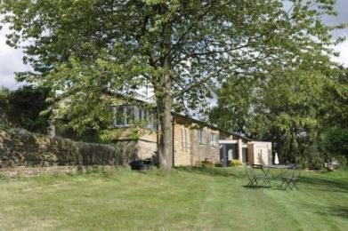
Exterior view of whole building

Arrival

Path to main entrance
- From the street to the main entrance, there is level access.
- The path is 2000mm wide, or more.

Main entrance
- The main entrance has level access.
- The main door is side hung and manual.
- The door is 830mm wide.
- When you arrive, we can help carry your luggage.
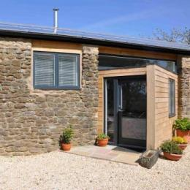
Cherry Tree Barn Front Door

Getting around inside

Visual Impairment - General Information
- We have high colour contrast between walls and doorframes.

Bedrooms
- All bedrooms have windows.
- Bedrooms have ceiling lights and bedside lamps.
- Lights are LED and energy saving.All bedrooms are non-smoking.
- We have non-allergic bedding.
- All bedrooms have fitted carpets.
- All bedding is washed with non biological liquid
- We can move the bedroom furniture, to improve accessibility.
- No bedrooms have level access.The bedroom nearest the main entrance has 5 steps.
- We have bathrooms with a bath and overhead shower.

Washing machine provided in Kitchen
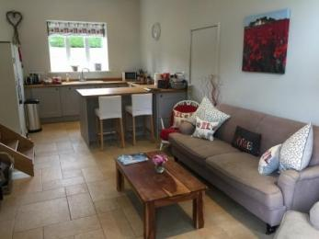
- From the main entrance to the laundry, there is level access.The route is 2500mm wide, or more.We have an iron and ironing board.

Self catering kitchen

Kitchen
- We have an open plan kitchen.
- From the main entrance to the kitchen, there is level access.
- The route is 900mm wide, or more.
- The work surface is available with clear underspace and available at a height between 650mm and 900mm.
- The hob is available at a height between 650mm and 900mm.
- The sink is available at a height between 650mm and 900mm.
- The oven is available at a height between 650mm and 900mm.
- The table and plates have high colour contrast.
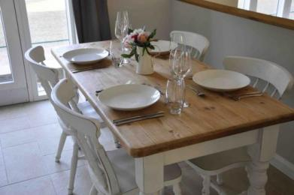

Lounge

Lounge
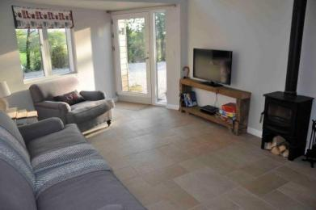
- From the main entrance to the lounge, there is level access.The route is 2500mm wide, or more.

Swimming pool

Swimming Pool
- From the main entrance to the swimming pool changing area, there are 3 steps. There is no lift and no ramp.
- From the changing area to the swimming pool, there are 2 steps. There is no lift and no ramp.
- There are integral steps in the pool to allow easy access for those with restrcited mobility. Changing is either in Cherry Tree Barn or you can change in the pool room adjacent to the pool. The pool is accessed by steps from the back of Cherry Tree Barn.
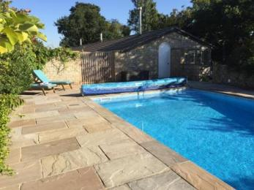
Swimming Pool

Gym

Gym
- From the main entrance to the gym changing area, there are 2 steps. There is no lift and no ramp.
- From the changing area to the gym, there are 3 steps. There is no lift and no ramp.
- The gym (with running machine and stepper) is in the pool room adjacent to the pool.

Getting around outside

Gardens
- From the main entrance to the gardens, there is level access.
- The route is sloped.
- The gardens surround Cherry Tree Barn and some of the garden is on a slope
Gardens

Tennis court
- From the main entrance to this area, there is level access.
- The tennis court is located at the back of Cherry Tree Barn, straight out the back door. Alternatively it can be accessed around the side of the barn via either a slope or steps.
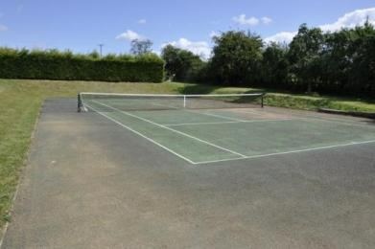
Tennis Court

Customer care support

Accessibility equipment
- No dogs are allowed as we are pet free accommodation

Customer care support
- Staff are available 24 hours a day.
- Owners live on site next door to Cherry Tree Barn

Guide last updated: 10 November 2017

